Name- Shivraj S
Course Name - Data Analytics with GenAI
Subject - Tableau
Topic - Calculated Fields, Parameters & LOD
Expressions
Contact Number - 8660636345
Email ID – shivarajshooru@gmail.com
Tableau Workbook – Link

Question 1:

What is a Calculated Field and why is it important in business dashboards?

A Calculated Field in Tableau is a custom field you create by writing a formula, instead of relying only on the raw data coming from your source. It allows you to derive new values, perform transformations, or apply business logic that isn’t directly available in the dataset.
A field created using formulas (like arithmetic, logical conditions, or functions). Can be based on existing fields in your dataset.
Examples:
Profit Margin = (SUM(Profit) / SUM(Sales)) * 100
Categorizing sales into “High”, “Medium”, “Low” using an IF statement.

Why It’s Important in Business Dashboards
Adds Business Logic
You can embed KPIs like conversion rate, profit margin, or customer churn directly into dashboards.

Flexibility
Lets analysts adapt dashboards to changing business needs without altering the underlying database.

Actionable Insights
Helps management see metrics that matter (e.g., “Top 10 products by revenue” instead of just raw sales).

Data Transformation
You can clean, categorize, or bucket data (e.g., grouping ages into ranges).
Dynamic Analysis
Enables scenario analysis, ratios, and conditional logic that drive decision-making.
Question 2:

Why can’t parameters change visuals directly in Tableau?
Parameters are independent values: A parameter is just a single global input (like a slider, dropdown, or text box). It doesn’t know what to do with the data until you connect it to a calculated field or filter logic.

No automatic link to data: Unlike filters, parameters don’t directly interact with the data source. They simply hold a value.

Need a bridge: To affect visuals, you must use that parameter inside a calculated field or reference it in a filter. That calculated field then drives the visualization.

Question 3:
When should EXCLUDE LOD be used?
The EXCLUDE Level of Detail (LOD) expression in Tableau is used when you want to remove certain dimensions from the view’s granularity while still calculating an aggregate. In other words, it lets you compute a value at a broader level than what your visualization is currently showing.
When to Use EXCLUDE LOD
You use EXCLUDE when:
You want to ignore a dimension in the view
Example: Your view shows Sales by Region and State, but you want to calculate Sales by Region only, ignoring the State breakdown.
You need a higher-level aggregate alongside detailed data
Example: Show each State’s sales, but also display the Region’s total sales next to it.
You want to compare detail vs. summary
Example: Calculate the difference between State Sales and Region Sales.

Question 4:
Difference between FIXED and INCLUDE LOD expressions?
FIXED and INCLUDE are two types of Level of Detail (LOD) expressions in Tableau, but they behave very differently. Let’s break it down clearly:

FIXED LOD
Definition: Calculates a value at a specific dimension level, independent of what’s in the view.
Behaviour: Ignores the visualization’s granularity and uses exactly the dimensions you specify.
Use Case:
You want Region-level sales even if your view is showing data at State or City level. FIXED is great for creating consistent KPIs that don’t change when filters or dimensions in the view change (except when filters are applied before FIXED, like context filters).

INCLUDE LOD
Definition: Calculates a value at a finer level of detail than the view, then rolls it back up.
Behaviour: Adds extra dimensions into the calculation, but results are aggregated back to the view’s granularity.

Use Case:
Your view is at region level, but you want the average of city-level sales per region.
INCLUDE lets you drill down temporarily to a finer grain, then summarize back up.
Use FIXED when you want a calculation at a specific level, unaffected by the view.
Use INCLUDE when you want to add detail temporarily to a calculation, then aggregate back to the view level.

Practical Questions:
1. In Tableau, go to the Data pane (left side)
2. Click on Analysis menu (top) → Create Calculated Field
3. Name it: Delivery Status
4. Enter this formula:
IF [Delivery_Time_Min] <= 30 THEN "Fast"
ELSE "Delayed"
END
5. Click OK
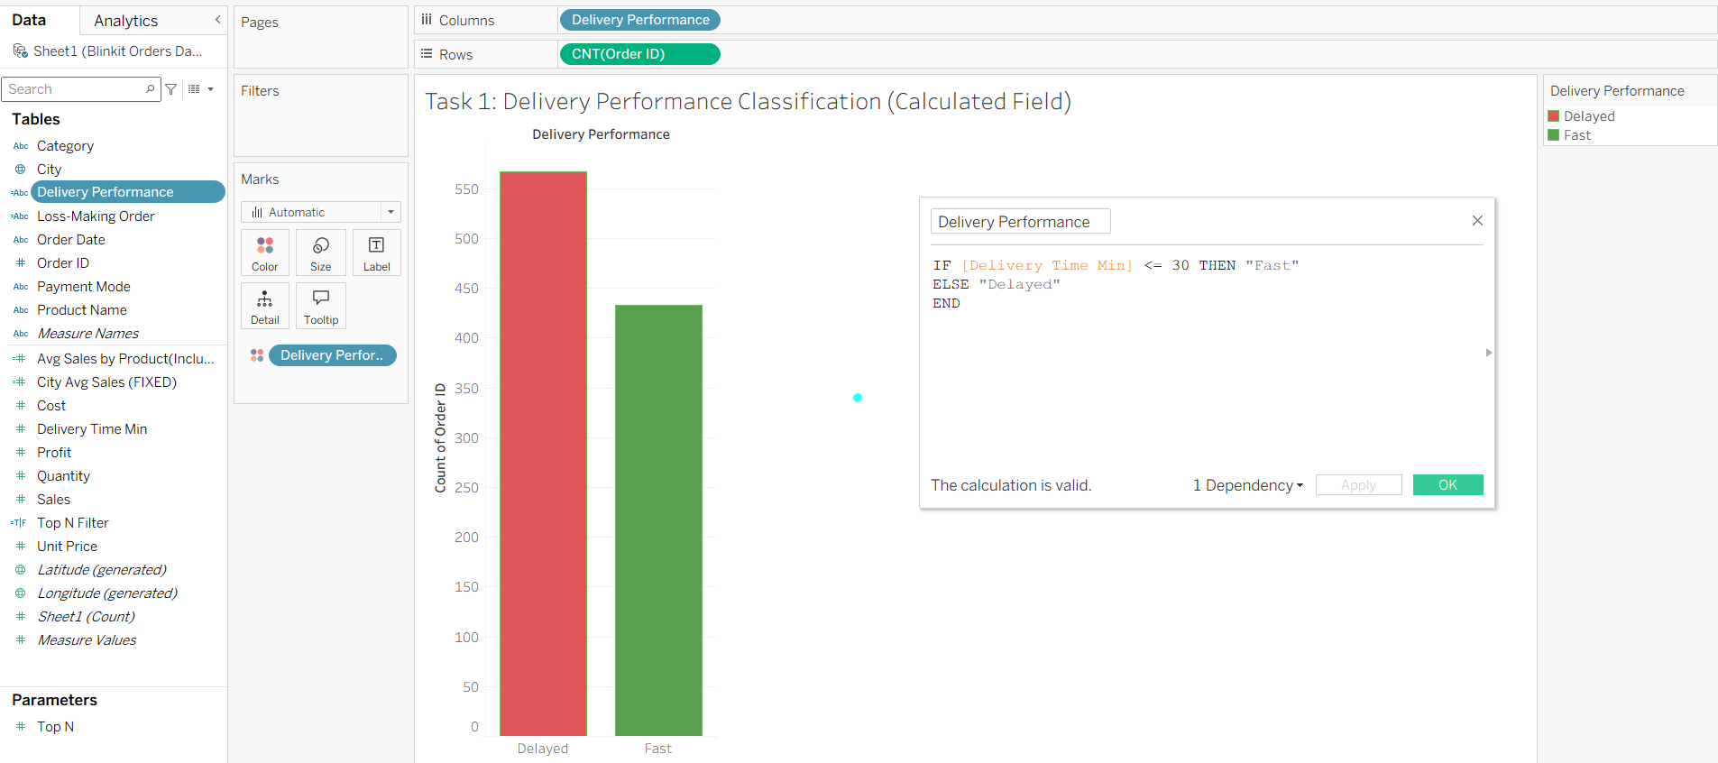

Task 2: Loss-Making Orders Identification
Goal: Flag orders where Profit < 0
Steps:
1. Create a new Calculated Field
2. Name it: Order Type
3. Formula:
IF [Profit] < 0 THEN "Loss"
ELSE "Profitable"
END
4. Click OK
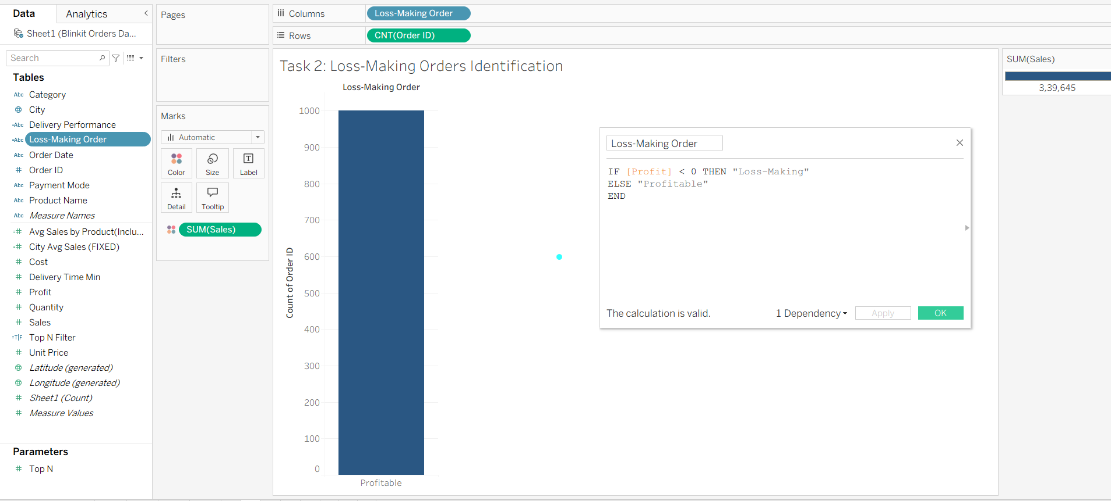

Task 3: Top N Products Analysis (Parameter)
Goal: Let the user dynamically choose to see Top 5, Top 10, Top 15 products by Sales
Steps — Part A: Create the Parameter
1. Right-click in the Data pane → Create Parameter
2. Settings:
o Name: Top N
o Data type: Integer
o Current value: 5
o Display format: Automatic
o Allowable values: Range → Min: 1, Max: 20, Step: 1
3. Click OK
Steps — Part B: Create a Calculated Field using the Parameter
1. Create a new Calculated Field
2. Name it: Top N Filter
3. Enter the Formula: RANK(SUM([Sales])) <= [Top N]
4. Click OK
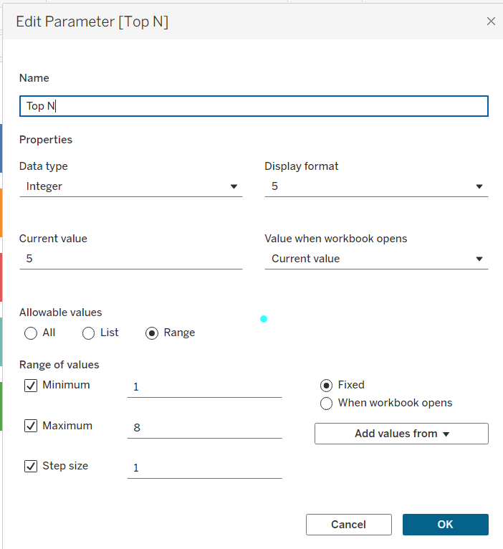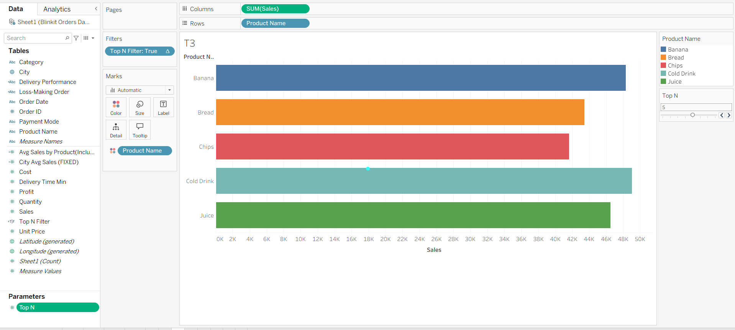

Task 4: City-Level Benchmarking (FIXED LOD)
Goal: Calculate average sales per city — and this value should NOT change even if you
apply a Category filter
Steps:
1. Create a new Calculated Field
2. Name it: City Avg Sales (FIXED)
3. Formula:
{ FIXED [City] : AVG([Sales]) }
4. Click OK
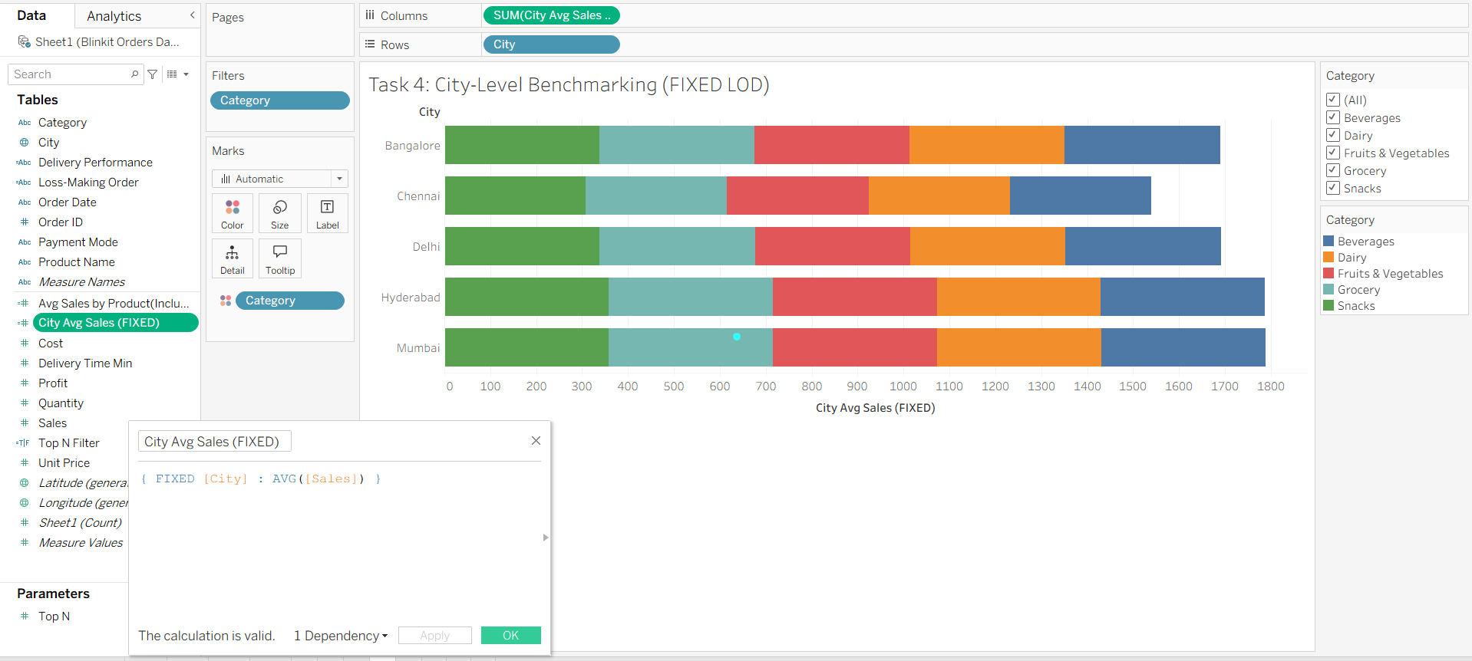

Task 5: Customer/Product Detail Impact (INCLUDE LOD)

